Department wise comparison Dashboard

This dashboard shall enable the users (senior management and HR) to see the comparison of data on various parameters (recognition trend, employee to manager ratio, PIP count & Rating distribution, risk distribution, count of polls, productivity, attrition) across the departments for the time period selected.

**Version: 1.0**

**Date: 02-Dec-2020**

*All rights reserved. No part of this publication may be reproduced, transcribed, transmitted, stored in a retrieval system or translated into any language, in any form or by any means mechanical, manual, electronic, magnetic, chemical, optical, including photocopying or otherwise without the prior written permission of UPRAiZAL, Inc.*

Contents

Revision History 4

Requirement 5

Implementation Method 6

Code Modifications 6

**Recognition Trend Dashboard:** 6

**File Path** 6

**Purpose** 6

**Modifications** 6

**File Path** 6

**Purpose** 6

**Modifications** 7

**File Path** 7

**Purpose** 7

**Modifications** 7

**Employee to Manager Ratio:** 8

**File Path** 8

**Purpose** 8

**Modifications** 8

**File Path** 9

**Purpose** 9

**Modifications** 9

**File Path** 9

**Purpose** 9

**Modifications** 10

**File Path** 10

**Purpose** 10

**Modifications** 10

**File Path** 11

**Purpose** 11

**Modifications** 11

**File Path** 11

**Purpose** 11

**Modifications** 11

**File Path** 12

**Purpose** 12

**Modifications** 12

**File Path** 12

**Purpose** 12

**Modifications** 12

**File Path** 13

**Purpose** 13

**Modifications** 13

**Risk Distribution:** 14

**File Path** 14

**Purpose** 14

**Modifications** 14

**File Path** 15

**Purpose** 15

**Modifications** 15

**Count Of Pulse Polls:** 17

**File Path** 17

**Purpose** 17

**Modifications** 18

**File Path** 18

**Purpose** 18

**Modifications** 18

**File Path** 18

**Purpose** 18

**Modifications** 19

**Employee Utilization:** 19

**File Path** 19

**Purpose** 19

**Modifications** 19

List of required Jars & File Paths 20

Use cases (Must for Unit Test) 21

# Revision History

|  |  |  |  |
| --- | --- | --- | --- |
| Version | Author | Date | Description |
| 1.0 | HYD0176SD | 09/Dec/2020 | Initial Version |

**Confidentiality**

The contents of this document are considered confidential and proprietary information of UPRAiZAL, Inc. No part of this document may be reproduced, fully or in part, or divulged to any other party without prior written permission from UPRAiZAL, Inc. All logos of respective owner companies used in this presentation are recognized.

# Requirement

Dashboard wise requirements are:

* **Recognition Trend** – System shall allow the user to visualize trend of number of employees in the departments who have bagged organization wide Recognitions in the Digital Workspace for the selected period.

**Line Chart:** For X – Axis: Time period, Y – Axis: Count of employees in various departments.

* **Employee to Manager Ratio** - System shall allow the user to visualize ratio of ‘number of employees’ to ‘number of managers’ in each department within the organization

**Bar Chart:** For X- Axis: Departments, Y – Axis: Count (Employee to Manager Ratio)

* On click of the Dept Bar a drill down to another Chart (Stacked Bar) should enable. This chart shows the Managers within the dept that was clicked. Stacked Chart - X Axis shows the Manager Names, Stacked Chart - Y Axis shows the Count of employees.
* In case the employees reporting to the manager are from different departments, they will show up as separate sections of the Stacked Bar Chart.
* **PIP Count and Rating Distribution** - On Clicking the PIP button, Bar chart will be displayed. On clicking Rating button, Line chart will be displayed.
* **PIP Count distribution** – Displays count of PIP employee distribution across the departments. Bar Chart: X – Axis: Departments, Y – Axis: PIP count of the employees in the department.
* **Rating distribution** – Displays rating distribution across the departments (to see how each departments Rating Curve looks like)

**Line Chart:**  X- Axis will have rage of ratings or scores of bin (Ex: 0 to 1, 1 to 2, 2 to 3,

3 to 4, 4 to 5), Y-Axis will have count of employees in the department with the

ratings achieved.

* **Risk Distribution** - Stacked Bar Chart with 3 values - Will show Low Risk, Medium Risk, High Risk across the departments being compared.

**Bar Chart:** X- Axis: Risk count, Y-Axis: Departments wise (High, Med, Low)

This chart has 2 levels of drill down

On Click of any bar – 1st level drill down to show the High-Risk Distribution - it will show a pie chart with % of risk split between ‘Polls based risk’ and ‘Events based risk’

On click of Polls or Events on Pie Chart – it will show a Bar chart with top 5 categories of Risk whether Polls Related Categories or Event Logs related categories.

* **Department Productivity** – ‘Employee Utilization’ - for selected period - count of employee where task count is equal to or greater than one / total count of employees
* **New Hire / Attrition** – This is a clustered Bar Chart which shows ‘No. of New Hires’ v/s ‘No. of Exits’ for each department of the organization

This has 2 levels of Drill down :1st level Drill down will show – split of New Hires and Exits counts based on their role. Like how many Managers Hired and how many Exited.

2nd level drill down is a report to show the data in a tabular format – The Name / Title /

‘Date Of Hire’ or ‘Date of Exit’ of the employees who have been hired or have exited the Dept.

# Implementation Method

Used Spring MVC based rest calls for get the data for each dashboard

# Code Modifications

## **Recognition Trend Dashboard:**

## **File Path**

“/upraizal-dashboard/src/main/java/com/defteam/dashboard/controller/DepartmentWiseComparisonController.java"

## **Purpose**

* Added Rest call to get the “Recognition Trending” service.

## **Modifications**

* Rest call

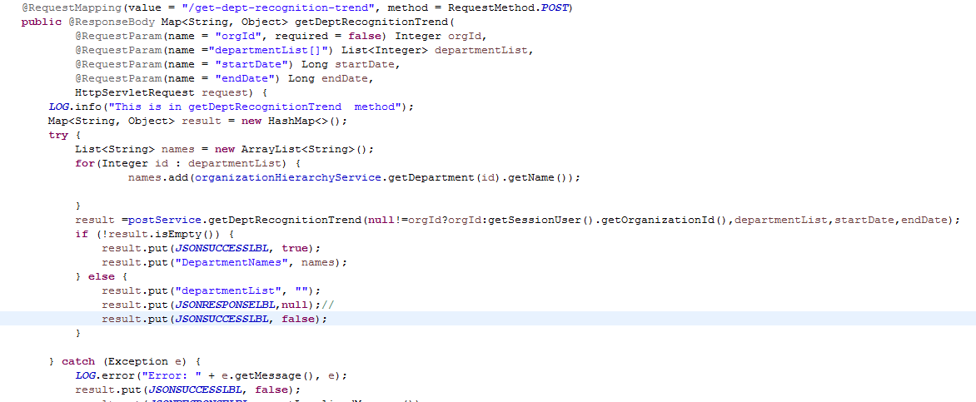

## **File Path**

“/upraizal-emp/src/main/java/com/defteam/emp/bpo/PostBPOImpl.java"

## **Purpose**

* Added Business logic to the “Recognition Trending” service.

## **Modifications**

* Business Logic

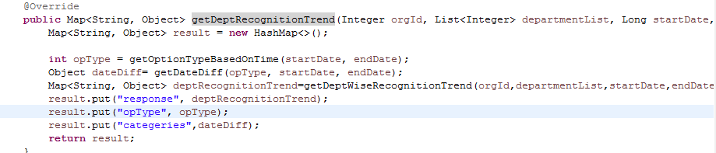

## **File Path**

“/upraizal-emp/src/main/java/com/defteam/emp/dao/PostDAOImpl.java"

## **Purpose**

* Added Data base query to get the Recognition Trending data based on the Employees and date filter

## **Modifications**

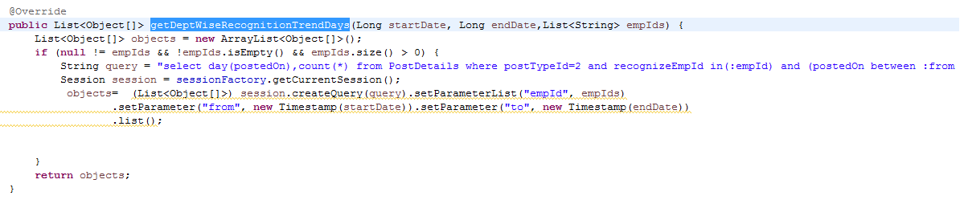

## **Employee to Manager Ratio:**

## **File Path**

“/upraizal-dashboard/src/main/java/com/defteam/dashboard/controller/DepartmentWiseComparisonController.java"

## **Purpose**

* Added Rest call to get the Employee to Manager Ratio service.

## **Modifications**

Rest call for Employee to Manager Ratio based on selected departments

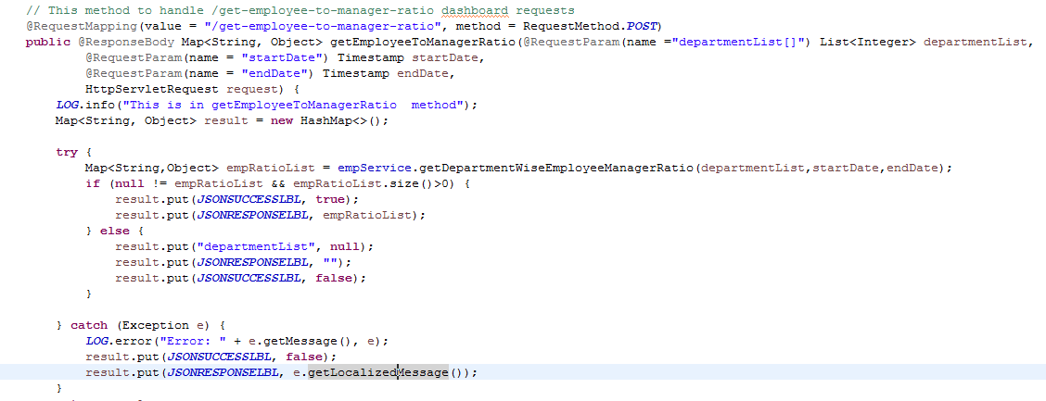

Drill down services for to get each manager and his/her repartees count based on the selected department

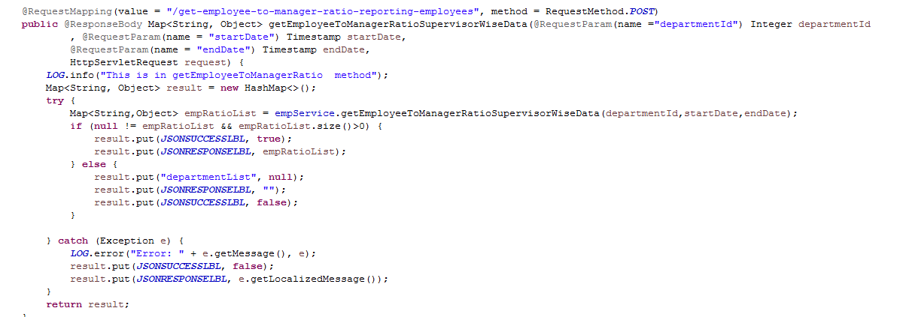

## **File Path**

“/upraizal-emp/src/main/java/com/defteam/emp/bpo/EmpBPOImpl.java "

## **Purpose**

Added Business Logic for Employee to Manager Ratio

## **Modifications**

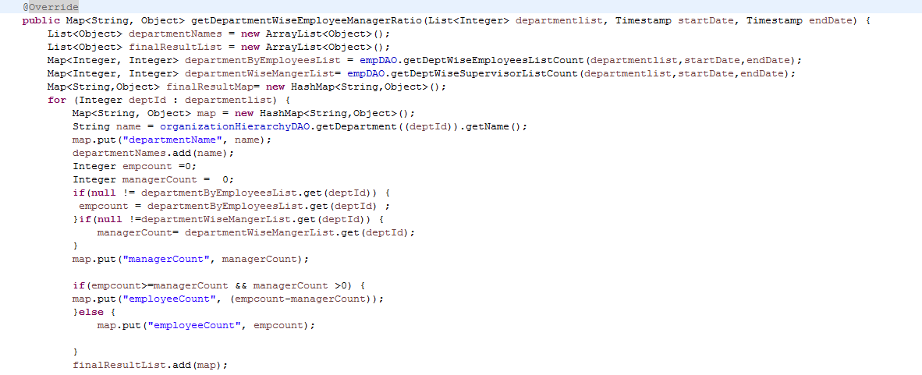

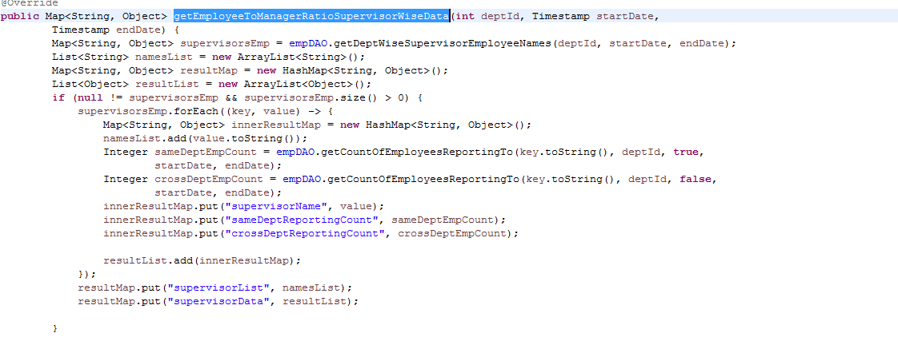

## **File Path**

" /upraizal-emp/src/main/java/com/defteam/emp/dao/EmpDAOImpl.java "

## **Purpose**

* Added data base query logic for to fetch the data for Employee to Manager Ratio.

## **Modifications**

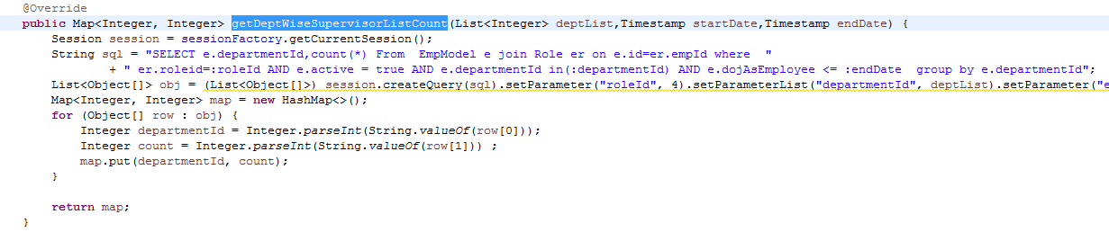

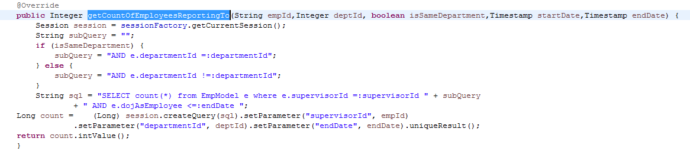

**PIP Count distribution:**

## **File Path**

* “/upraizal-dashboard/src/main/java/com/defteam/dashboard/controller/DepartmentWiseComparisonController.java"

## **Purpose**

* Rest call for PIP Employees Count on selected departments

## **Modifications**

* Rest call

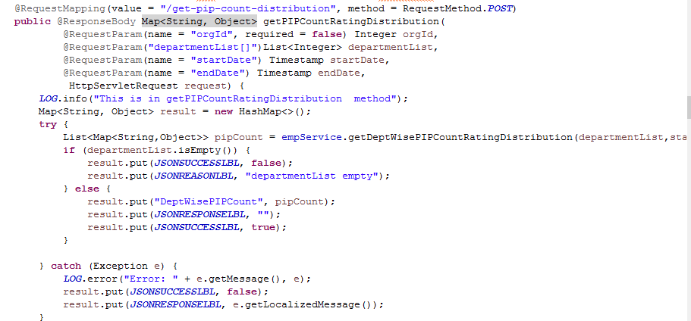

## **File Path**

* “/upraizal-emp/src/main/java/com/defteam/emp/bpo/EmpBPOImpl.java"

## **Purpose**

* Business logic to get the PIP Count, who are fallen in the PIP.

## **Modifications**

* Business logic to get the required data

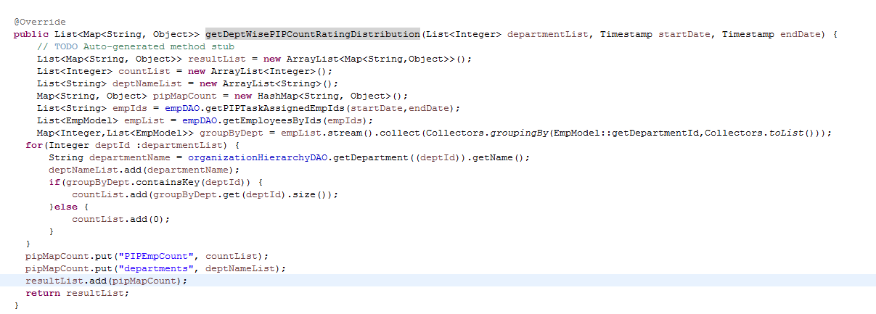

## **File Path**

* “/upraizal-emp/src/main/java/com/defteam/emp/dao/EmpDAOImpl.java"

## **Purpose**

* Added data base query logic for to fetch the data for PIP Count Distribution.

## **Modifications**

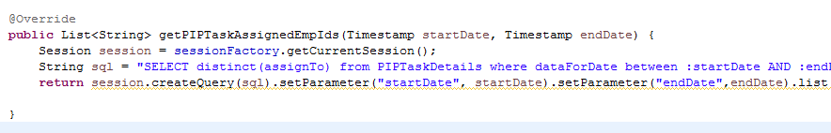

**Rating Distribution:**

## **File Path**

“/upraizal-dashboard/src/main/java/com/defteam/dashboard/controller/DepartmentWiseComparisonController.java"

## **Purpose**

* Rest call for Rating Distribution on selected departments

## **Modifications**

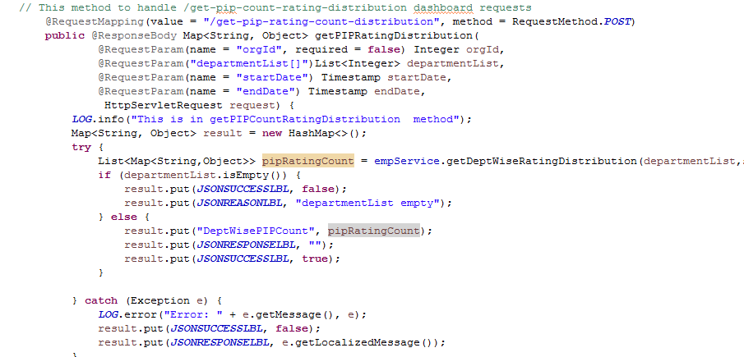

## **File Path**

“/upraizal-emp/src/main/java/com/defteam/emp/bpo/EmpBPOImpl.java"

## **Purpose**

* Business logic to get the Rating based on the scale in selected departments.

## **Modifications**

* Business logic to get the required data

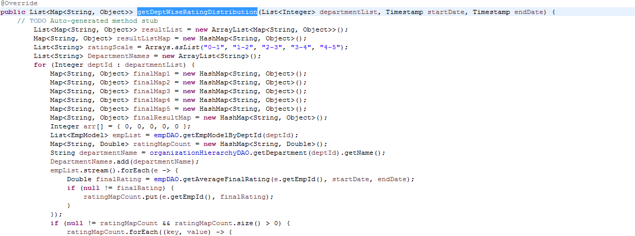

## **File Path**

* “/upraizal-emp/src/main/java/com/defteam/emp/dao/EmpDAOImpl.java"

## **Purpose**

* Added data base query logic for to fetch the data for Rating Distribution.

## **Modifications**

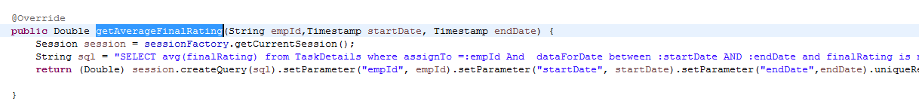

## **Risk Distribution:**

## **File Path**

“/upraizal-dashboard/src/main/java/com/defteam/dashboard/controller/DepartmentWiseComparisonController.java"

## **Purpose**

* Rest call for Risk Distribution on selected departments

## **Modifications**

* Department wise High Risk and Medium Risk And Low Risk

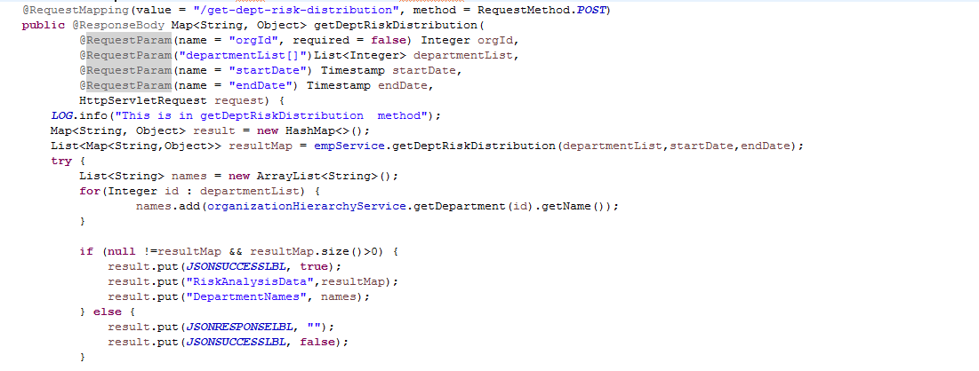

* Pulse Poll and Event Based High Risk percent

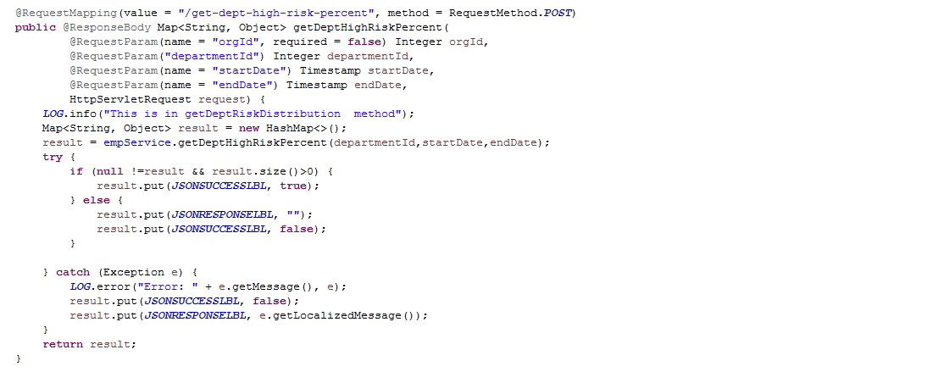

* Pulse Poll based top 5 High Risk categories

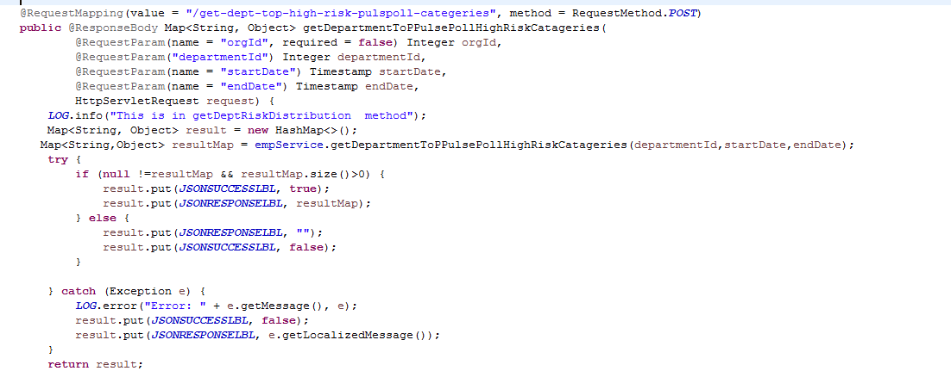

* Event based top 5 High Risk categories

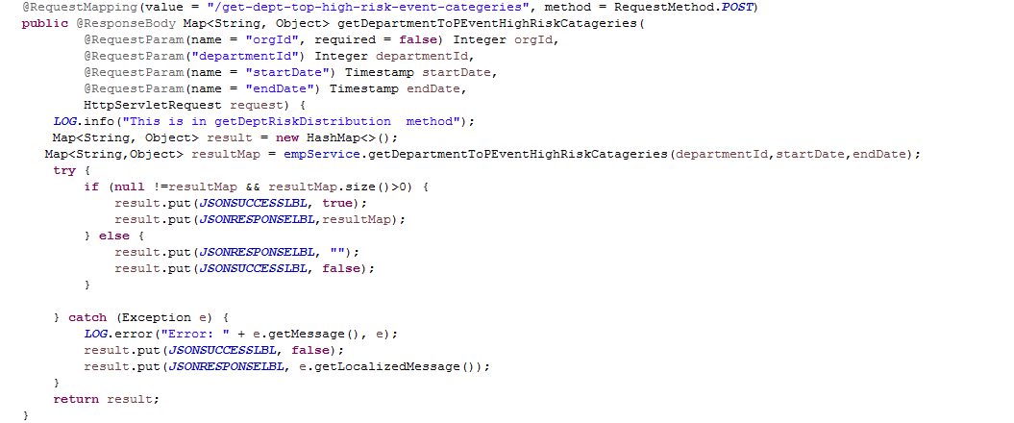

## **File Path**

“/upraizal-emp/src/main/java/com/defteam/emp/bpo/PulsePollBPOImpl.java"

“/upraizal-emp/src/main/java/com/defteam/emp/bpo/EmpElogBPOImpl.java”

## **Purpose**

* Business logic to get the Rating based on the scale in selected departments.

## **Modifications**

* Business logic to get the required data

Pulse Poll Based Risks:

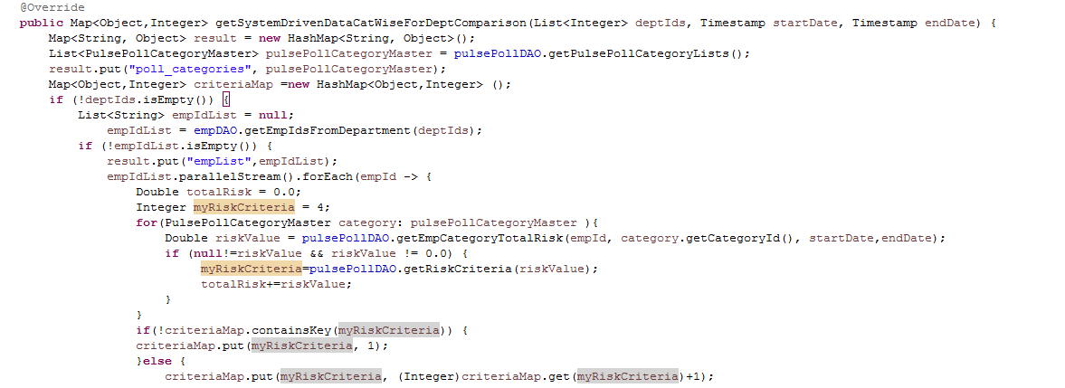

Events Based Risks:

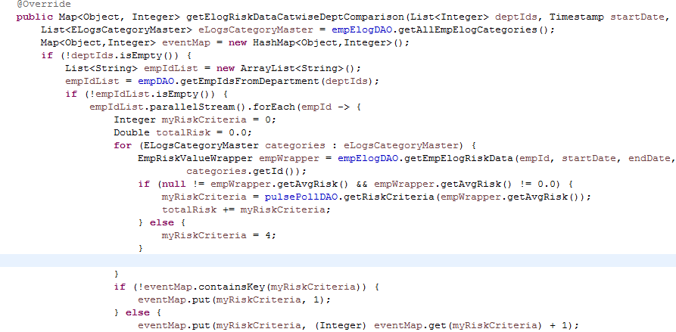

Pulse Poll Based Top 5 High Risk Categories: 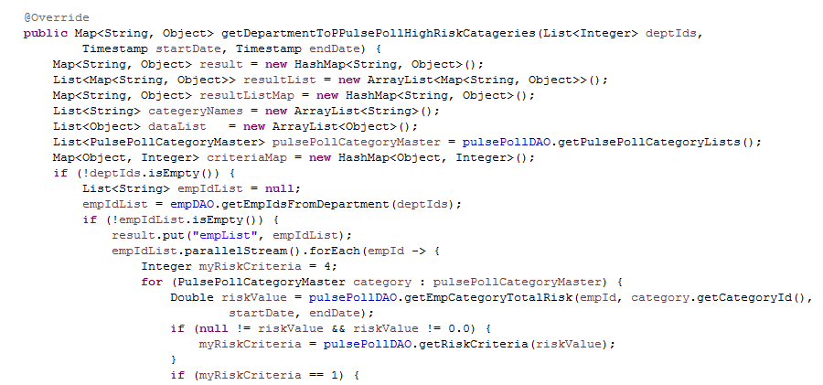

Event Based High Risk top 5 Categories:

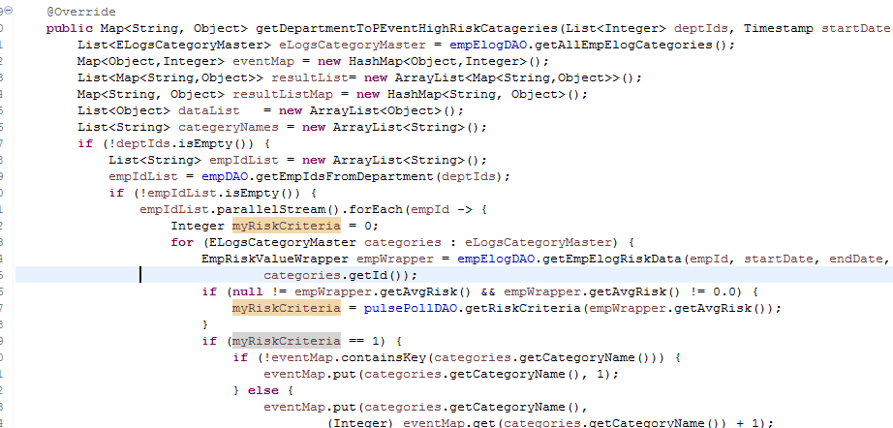

Note: Used Same Database queries for all the Risk-Distribution calculations.

## **Count Of Pulse Polls:**

## **File Path**

“/upraizal-dashboard/src/main/java/com/defteam/dashboard/controller/DepartmentWiseComparisonController.java"

## **Purpose**

* Rest call for Count Of Pulse Polls on selected departments

## **Modifications**

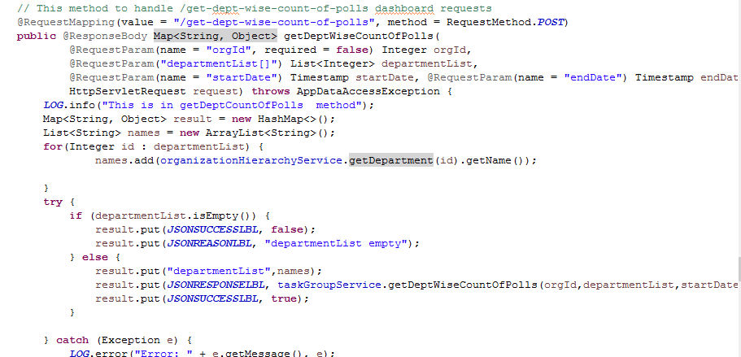

## **File Path**

“/upraizal-task/src/main/java/com/defteam/task/bpo/TaskGroupBPOImpl.java “

## **Purpose**

Business logic to get the Pulse Poll count in selected departments.

## **Modifications**

Pulse Poll Based count: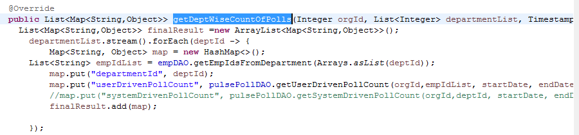

## **File Path**

“/upraizal-emp/src/main/java/com/defteam/emp/dao/PulsePollDAOImpl.java "

## **Purpose**

* Added data base query logic for to fetch the data for Pulse Poll Count.

## **Modifications**

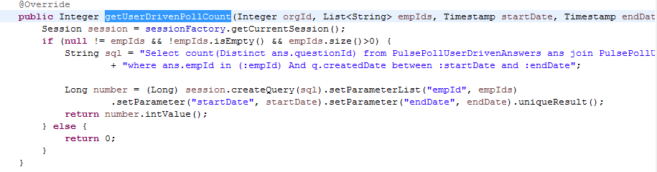

## **Employee Utilization:**

## **File Path**

“/upraizal-dashboard/src/main/java/com/defteam/dashboard/controller/DepartmentWiseComparisonController.java"

**Purpose**

* Rest call for Employee Utilization on selected departments

## **Modifications**

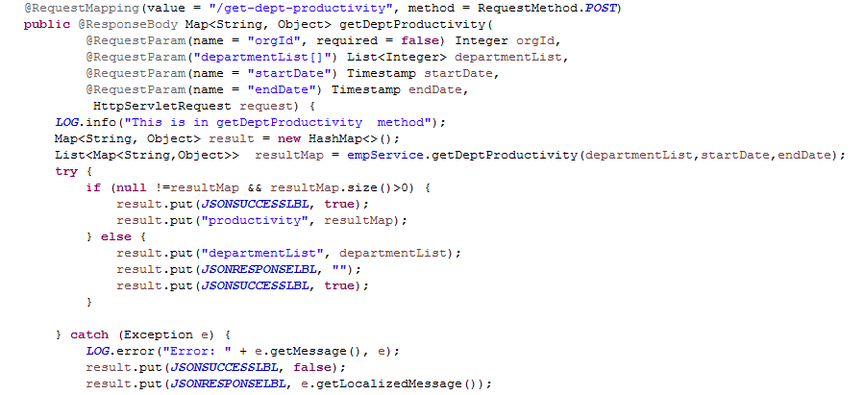

## **File Path**

“/upraizal-emp/src/main/java/com/defteam/emp/bpo/EmpBPOImpl.java"

## **Purpose**

* Business logic to get the Employee Utilization in selected departments.

## **Modifications**

* Business logic to get the required data

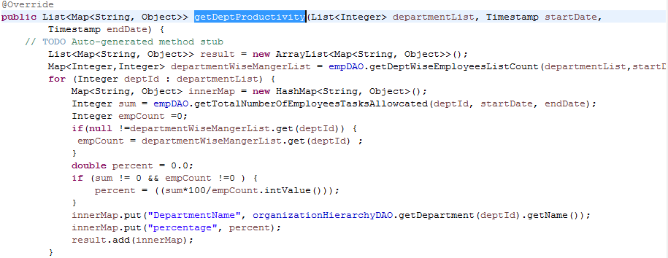

## **File Path**

* “/upraizal-emp/src/main/java/com/defteam/emp/dao/EmpDAOImpl.java"

## **Purpose**

* Added data base query logic for to fetch the data for Rating Distribution.

## **Modifications**

Data base query to fetch total Employees in Department wise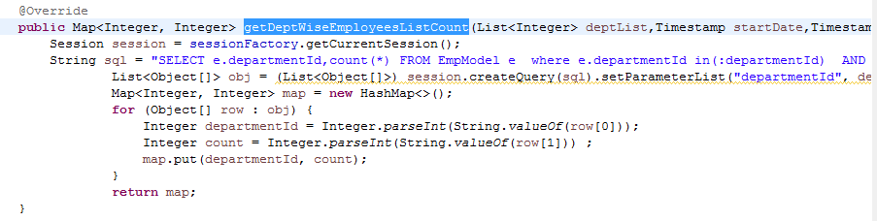

Data base query For Task Assigned Employees:

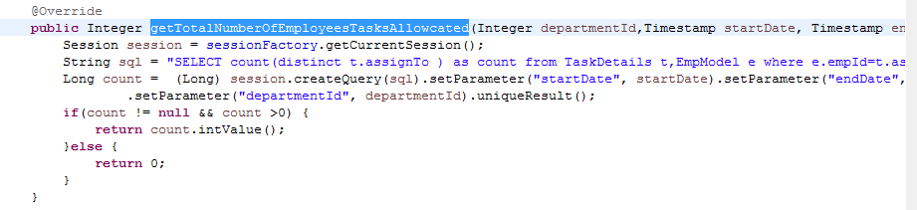

## **Employee Attrition:**

## **File Path**

“/upraizal-dashboard/src/main/java/com/defteam/dashboard/controller/DepartmentWiseComparisonController.java"

## **Purpose**

* Rest call for Employee Utilization on selected departments

## **Modifications**

* New Hire and Exit Employees count

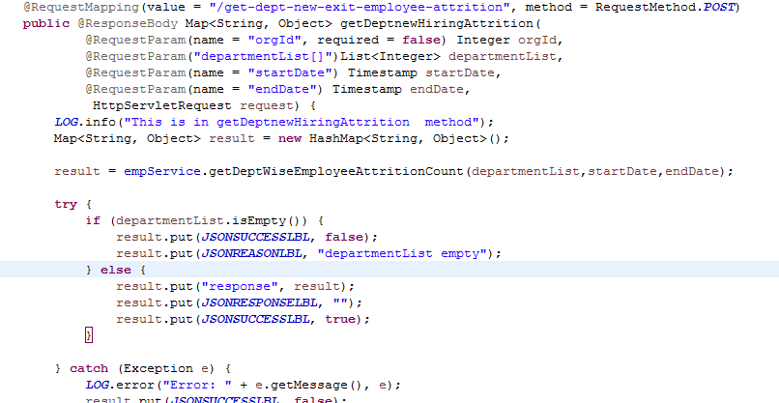

* Role wise count for New Hire and Exit Employees

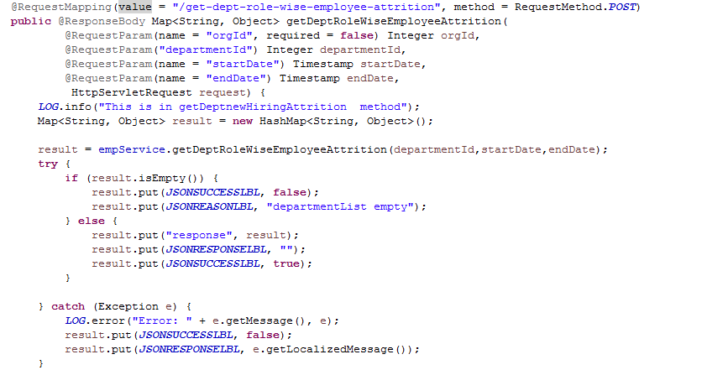

* Role wise New Hire Employees data to show tabular format

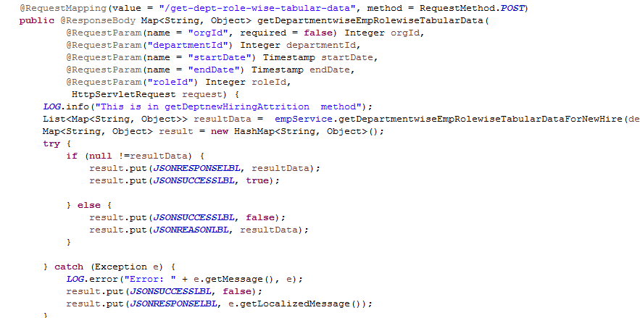

* Role wise Exit Employees data to show tabular format

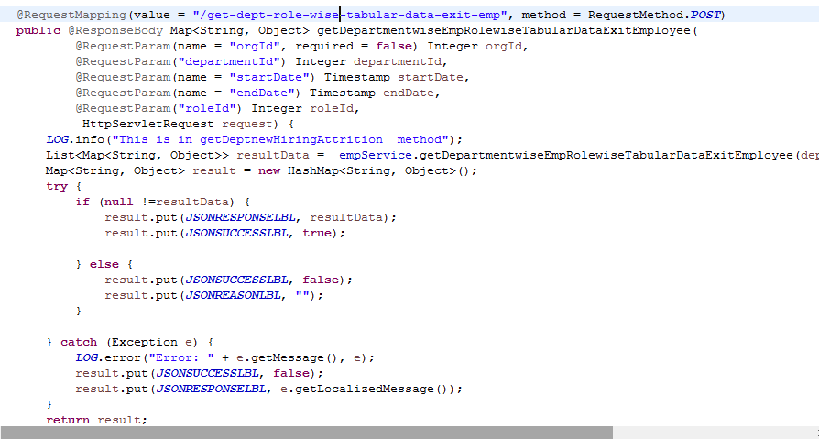

## **File Path**

“/upraizal-emp/src/main/java/com/defteam/emp/bpo/EmpBPOImpl.java"

## **Purpose**

* Business logic to get the Employee Attrition in selected departments.

## **Modifications**

* Business logic to get the department wise New Hire and Exit Employees count.



* Business logic to get the department Role wise New Hire and exit Employees count.

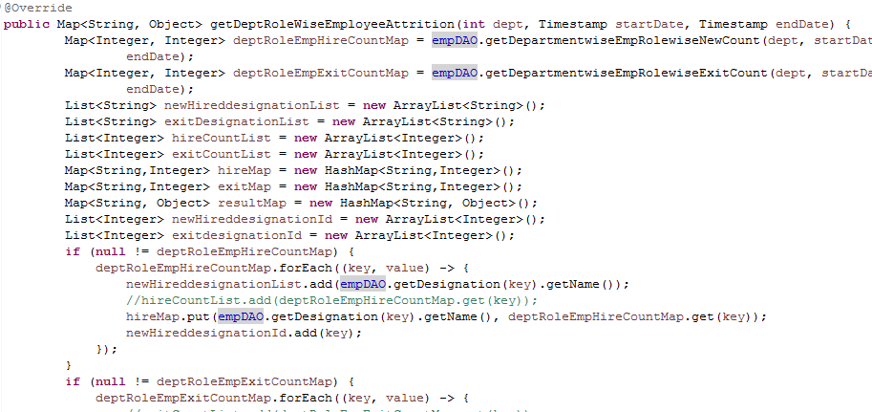

* Business logic to get the department Role wise New Hire Tabular Data

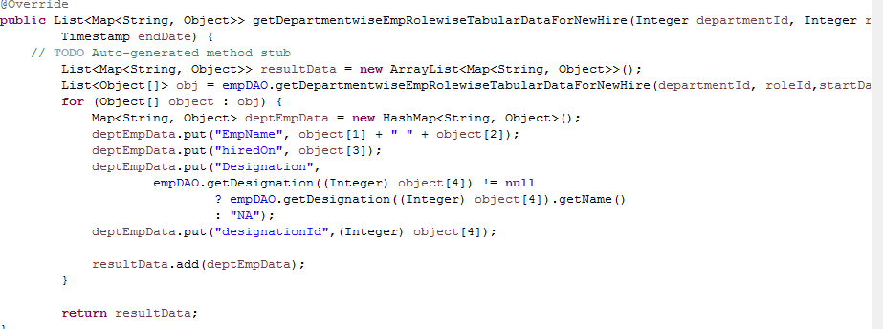

* Business logic to get the department Role wise Exit Tabular Data

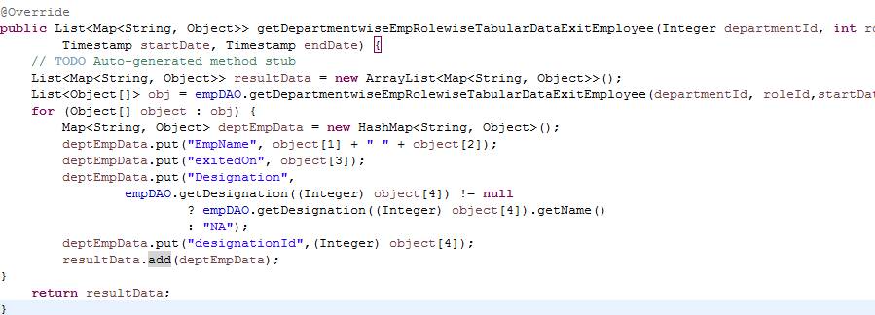

## **File Path**

“/upraizal-emp/src/main/java/com/defteam/emp/dao/EmpDAOImpl.java"

## **Purpose**

* Added data base query logic for to fetch the data for Employee Attrition.

## **Modifications**

* Data base query to fetch Business logic to get the department wise New Hire and Exit Employees count.

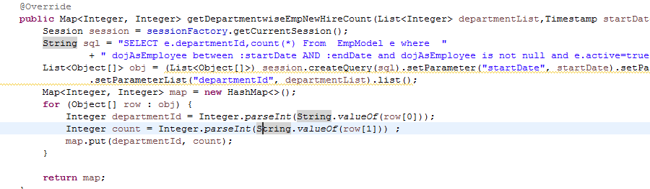

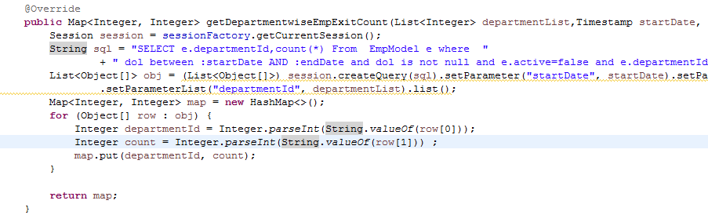

* Data base query to department Role wise New Hire and Exit Employees count.

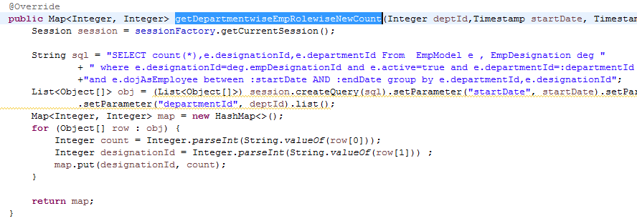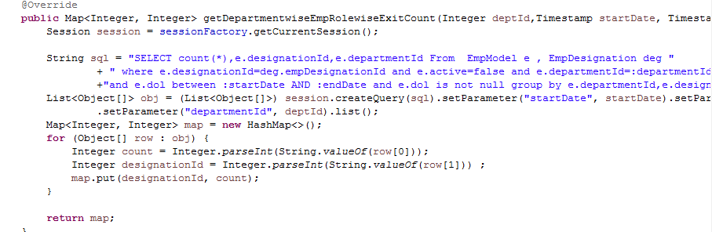

* Data base query to department Role wise New Hire Tabular Data.

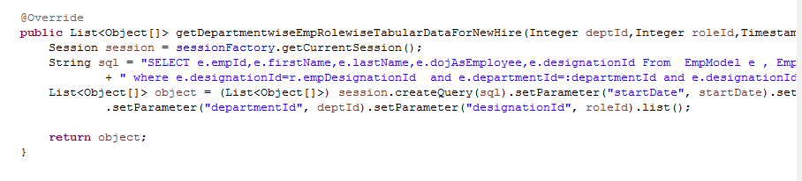

* Data base query to department Role wise Exit Tabular Data.

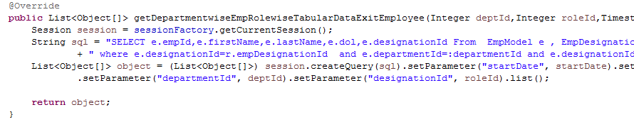

# List of required Jars & File Paths

* /upraizal-dashboard/src/main/java/com/defteam/dashboard/controller/DepartmentWiseComparisonController.java
* /upraizal-emp/src/main/java/com/defteam/emp/service/EmpService.java
* /upraizal-emp/src/main/java/com/defteam/emp/service/EmpServiceImpl.java
* /upraizal-emp/src/main/java/com/defteam/emp/service/EmpBPO.java
* /upraizal-emp/src/main/java/com/defteam/emp/service/EmpBPOImpl.java
* /upraizal-emp/src/main/java/com/defteam/emp/dao/PulsePollDAO.java
* /upraizal-emp/src/main/java/com/defteam/emp/dao/PulsePollDAOImpl.java
* /upraizal-task/src/main/java/com/defteam/task/bpo/TaskGroupService.java
* /upraizal-task/src/main/java/com/defteam/task/bpo/TaskGroupServiceImpl.java
* /upraizal-task/src/main/java/com/defteam/task/bpo/TaskGroupBPOImpl.java
* /upraizal-task/src/main/java/com/defteam/task/bpo/TaskGroupBPO.java
* /upraizal-task/src/main/java/com/defteam/task/bpo /EmpElogBPO.java
* /upraizal-task/src/main/java/com/defteam/task/bpo /EmpElogBPOImpl.java
* /upraizal-task/src/main/java/com/defteam/task/bpo /EmpElogDAO.java
* /upraizal-task/src/main/java/com/defteam/task/bpo /EmpElogDAOImpl.java

# Use cases (Must for Unit Test)